Update Page

At Metrici we are keen to keep our products up to date. As such, we have also included an update feature. To access it, go to the Home Page of the device and just press on the “Go to Update Page” blue button that is found in the lower right corner.

Pressing the button will redirect you to the Update Page:
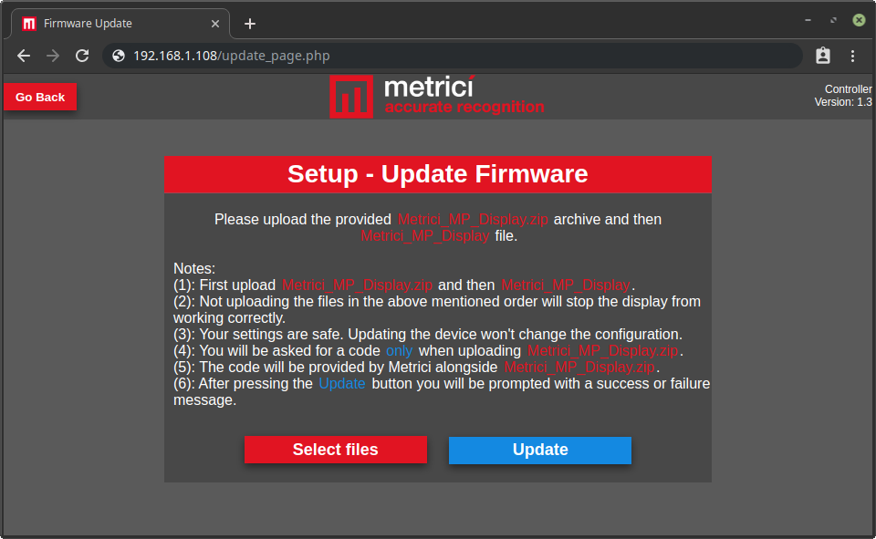
Here you have the possibility of uploading files one at a time. The files that you can upload, as specified in the notes that are found on this page, can only be “Metrici_MP_Display.zip” and “Metrici_MP_Display”.

You will always receive both files as part of an update. First, you will have to upload “Metrici_MP_Display.zip” (archive) and then “Metrici_MP_Display” (file). If you attempt to upload “Metrici_MP_Display” first you will be prompted with the following error: “Invalid file. Please upload a valid Metrici_MP_Display file !” . Please respect the given order, otherwise the update will not work.

Alongside the two files used for an update we will also provide a 32 character code. The code is only needed when uploading the first file: “Metrici_MP_Display.zip”.

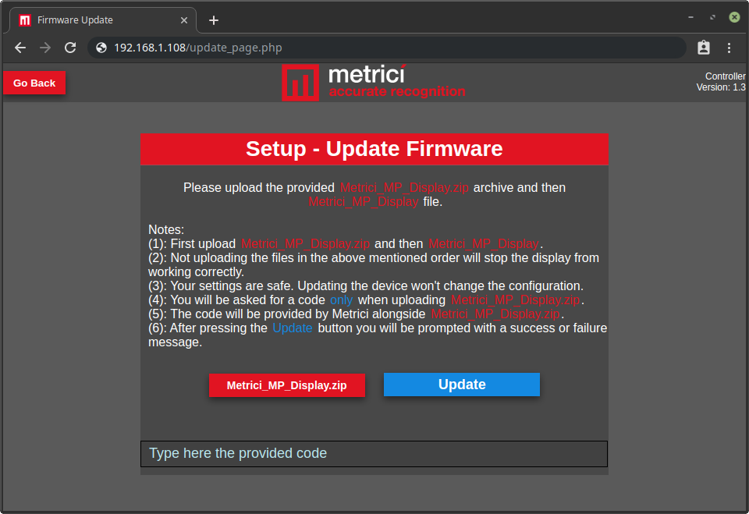
A proper uploading scenario should look like this:
- select “Metrici_MP_Display.zip” from your computer/device;
- enter the provided code in the input field;
- click on “Update” button;
- a prompt message will appear: “File successfully uploaded. Webserver was updated !”;
- click “Ok”;
- select “Metrici_MP_Display” from your computer/device;
- click on “Update” button;
- a prompt message will appear: "File successfully uploaded. Firmware was updated !";
- click “Ok”.

Congratulation ! You have just performed an update and you can enjoy the latest version of our product. If the uploaded files were the ones that were provided by Metrici, the update should work smoothly. Otherwise the update won’t go through.

